Annual Conference – 15 - 16 September 2017
Optional Activities
Optional activities all begin directly after the conference closes and guests attending any activities will be collected from the Marlborough Convention Centre, taken to the location of their chosen activity and returned back to their hotel (or a neighbouring hotel) in time to get ready for the formal dinner within the WWII display at the Omaka Aviation Centre.
- Collect a packed lunch as you leave the conference.
- Get changed if you need to for your activity.
- Hop on the correct bus for your activity
and you are off for an afternoon of enjoyment with colleagues, partners, friends.
Please note that it is the responsibility of guests to wear clothing and footwear appropriate for their chosen activity. Please bring this clothing with you to the conference on Saturday morning if you need to change.

Omaka WWI Exhibition and Omaka Classic Cars
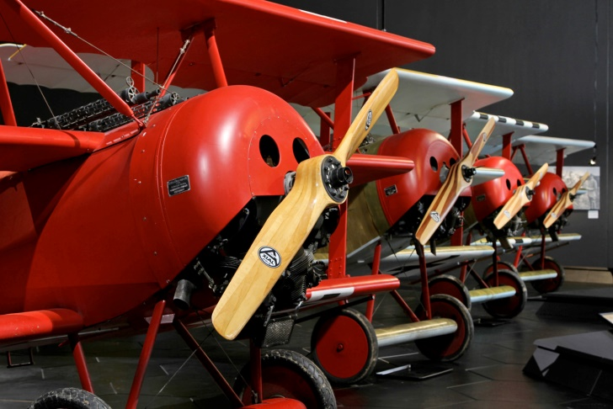
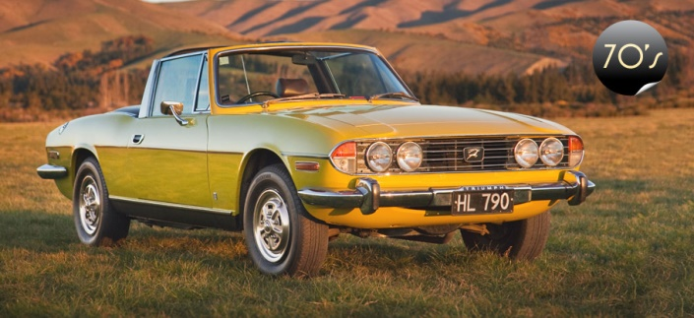
Guests are taken to the Omaka Aviation Museum and neighbouring Omaka Classic Car Museum. The WWII exhibition forms part of the formal dinner so this will be seen later but in this optional activity a tour guide will take you through the beautifully presented Knights of the Sky Omaka WWI Exhibition and entertain and inform with stories about the displays and the history behind them. After this enjoy a nostalgic wander through a substantial and interesting display of classic cars from 1950s through to 1980s at the neighbouring Omaka Classic Car Museum. A must visit for motoring enthusiasts. Note: Transportation to and from the town will be either by light railway or bus depending on the weather.
For more information, see http://omaka.org.nz/ww1.html
http://www.omakaclassiccars.co.nz/

Cycle or Walk the Link Pathway at Picton
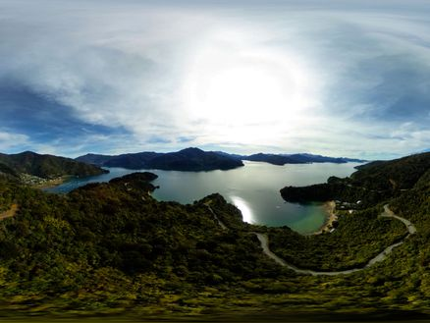
Guests will be collected from the Conference Centre and travel by bus to Picton where experienced Wilderness Guides will take two groups to part of the Link Pathway. Both groups will take in impressive views of Marlborough Sounds, listen to birdsong, breathe in the air and beauty.

Cycle
The cyclists will be left to travel at their own pace. Cycles and helmets provided.
Walk
The walking group will enjoy a guided tour.

For more information see https://www.marlborough.govt.nz/recreation/walking-and-biking/popular-tracks/the-link-pathway
Marlborough Region Garden Tour
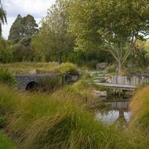
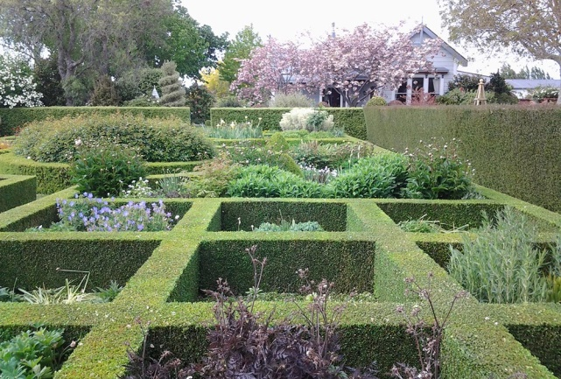
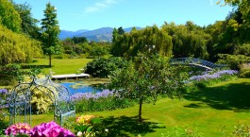
Guests are by bus from the Convention Centre to visit three very different Marlborough gardens, Hortensia House, Upton Oaks and Bhudevi Gardens. Tours through these three beautiful garden displays will give you the opportunity to wander, relax and enjoy your surroundings. There is also time to drop into the Makana Boutique Chocolate Shop for a taste and opportunity to purchase crafted handmade chocolate treats.
For more information see
https://marlboroughnz.com/listings/bhudevi-garden/
http://www.uptonoaks.co.nz/garden
http://hortensiahouse.co.nz/

Wine Tasting
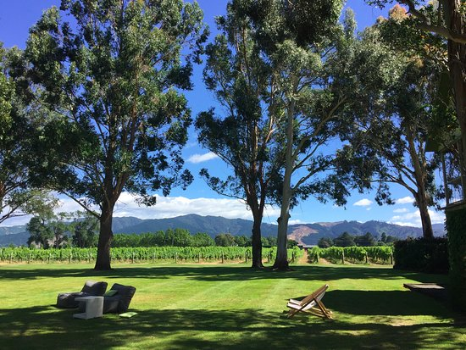
Modern Cloudy Bay, traditional Allen Scott and breathtaking Brancott Estate all offer beautiful and different vineyard and wine tasting experiences. You will not be disappointed if you choose this tour. Marlborough does wine well and the cellar door experts will guide you through their tasting package at each vineyard. Buses will take you from the Convention Centre to each of these vineyards for a unique experience.
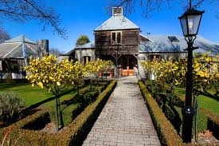
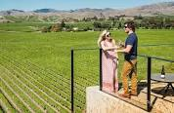
For more information see

Guided Sea Kayak
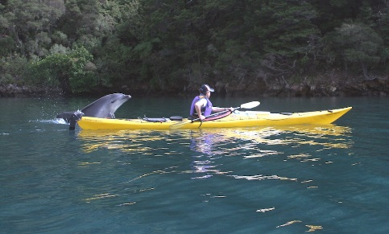
This limited numbers tour will take even novice kayakers on a guided sea tour of the sounds. Warm clothing a must but all other equipment is provided.
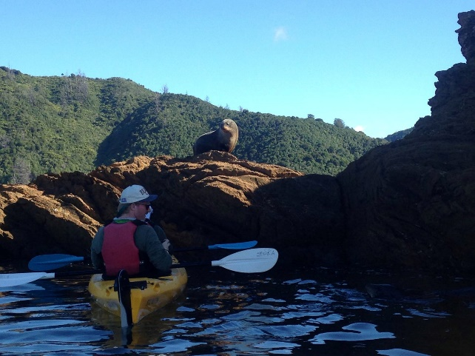
http://www.wildernessguidesnz.com/sea-kayaking/about-sea-kayaking/
Notes for all activities
Participant numbers for activities are limited, so early conference registration will secure your choice of activity.
Where activities are weather dependent, guests will be offered an alternative if bad weather requires cancellation of an activity. Please note that it is the responsibility of guests to wear clothing and footwear appropriate for their chosen activity. Please bring this clothing with you to the conference on Saturday morning if you need to change.

